1 : Install Docker,docker –version for chking, If you are using **Window 10** and are using **docker toolbox**

=> Use **192.168.99.100** instead of **localhost**.

**Note:**If **192.168.99.100** does not work, you can find the IP by using the command docker-machine ip



Is command me hub.docker.com se image download ki jaegi.(It is Public Registory.)



Image have (Java,all liberary and all dependency wiz required to run the application.)





We can use ctrl+c to stop running container.





-d is stands for detached mode so we will run image and when we will press ctrl + C or close CMD it will not stop our container.



With the help of docker logs container id gives logs

Docker logs -f gives trailing logs like if some logs are newly generated it will show us error.

Docker container ls gives details of all containers running.

We can run multiple container with same image you just need to change port numbers only.



Docker images command gives all images present in machine.

Docker container ls -a gives list of all containers even if they are not in running state.

Stop docker container by running command docker container stop containerID.

Docker architecture : docker client and docker demon (manages containers , Image, local Image ) it’s client server kind of architecture,if we pull image firist it will pull from local image if it’s not present in local then it will look for client which is docker registory docker hub.

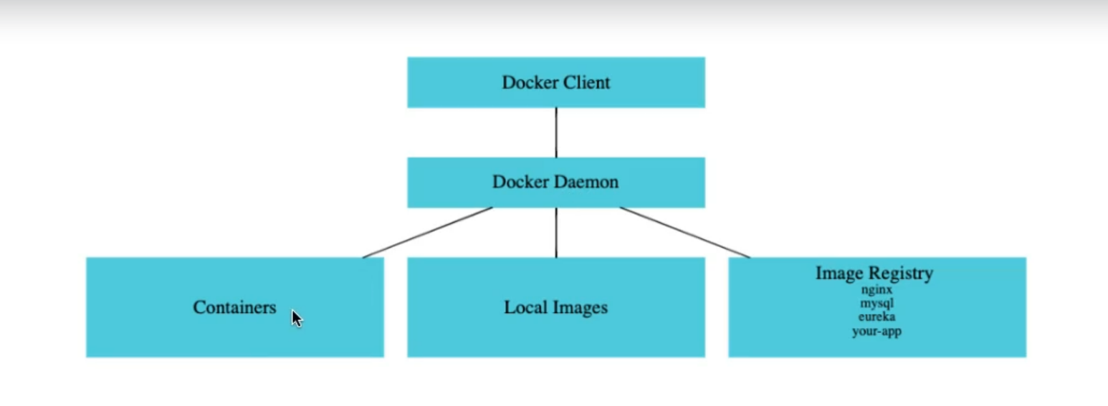

Docekr Demon can process instruction to create images as well.

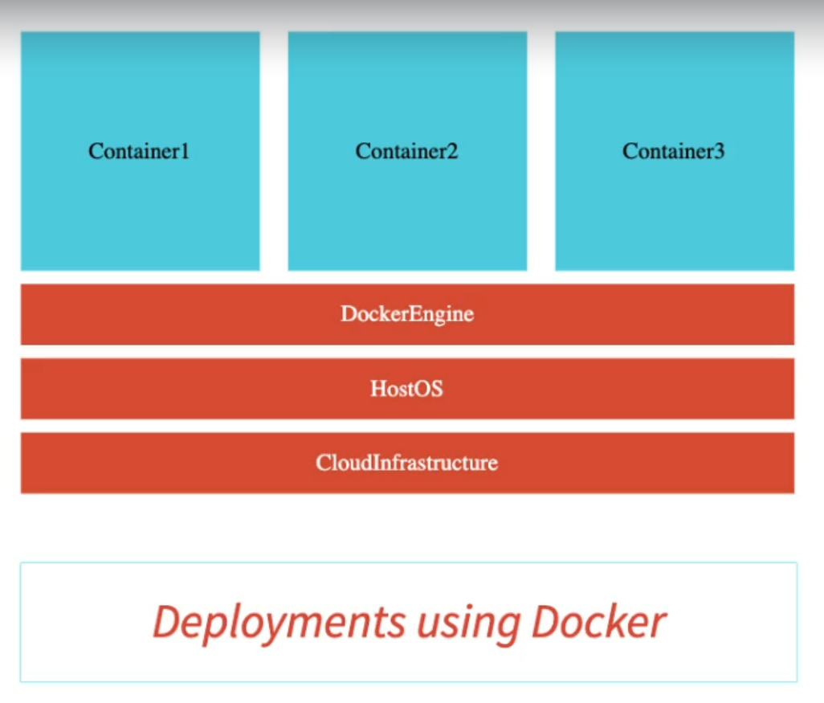

Hypervisor was used in VM to manage virtual machines.

Azure provides service is called Azure container service. AWS provides service called elastic containers.

We can put multiple tags to same images.





Docker pull mysql : Donloads image of mysql from registory to my local machine.docker search mysql gives all details about the weather image is present with that name or not.

Try to download official images because they meet standards.

To see history of image we can use docker image history imageID.

Docker Image inspect imageID : It will give all details like version exposed ports n all.

Docker image remove imageID : It will remove image from local machine only.

Command to run docker container : if we will not write container then also it will work fine.



Launching in detach mode :



We can also pause as well as unpause docker container : docker container pause containerID, docker container unpause containerID (Stops container in specific stage)

We can also use docker container inspect containerID.

Docker container prune this command will remove all the stopped container.

Docker container stop stops container gracefully means it will stop services and processes one by one but if we will use docker container kill containerID then it will kill all services immediately.



Restart policy have two options always (When we will restart docker desktop it will automatically restart container) and no and the default value is No.



Docker events : Traces events that happened when we fire any commands.

Docker top containerID: tells what is the top process which is running .

Docker stats : gives all stats regarding the container.

While running container we can define manually specific memory and we can also assign CPU quota

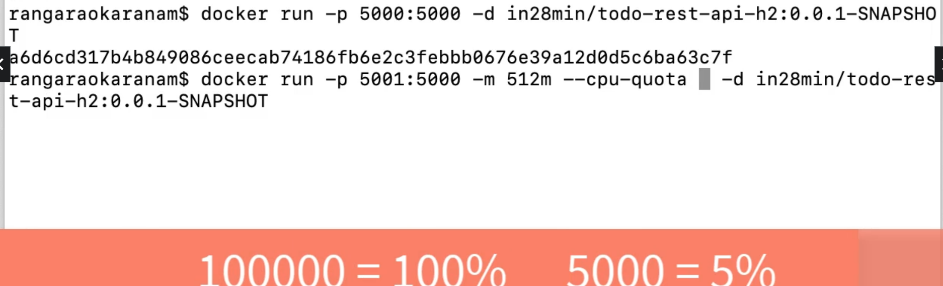

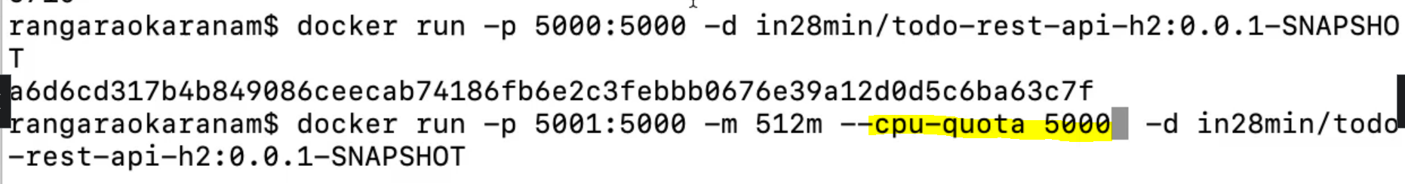

Docker system df : It also provide us details.

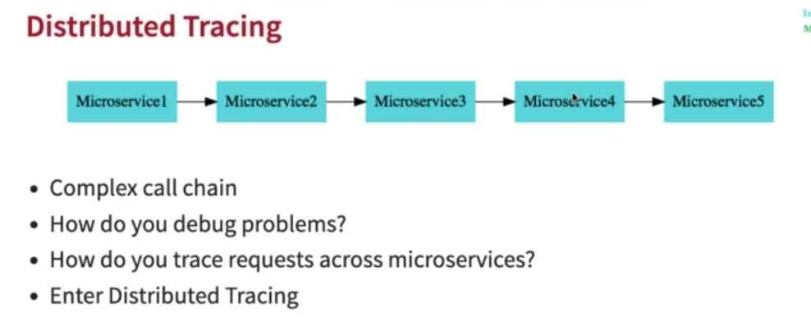

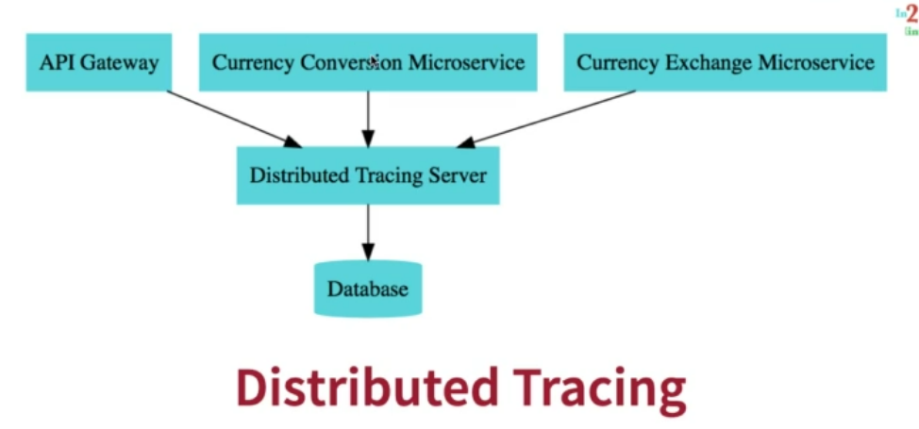

Zipkin is a distributed tracing system. It helps gather timing data needed to troubleshoot latency problems in service architectures.

